# Code Inspection for Admin Panel HTML

## Description of Landing Page:

The admin panel landing page is a structured, responsive interface designed to manage user accounts and sensor headers. It includes Bootstrap for layout responsiveness, custom stylesheets for UI theming (including dark mode), and JavaScript for interactivity. It presents a clear header, navigation bar, modals, and data tables, all within a coherent administrative dashboard.

**Interface Screenshot:**

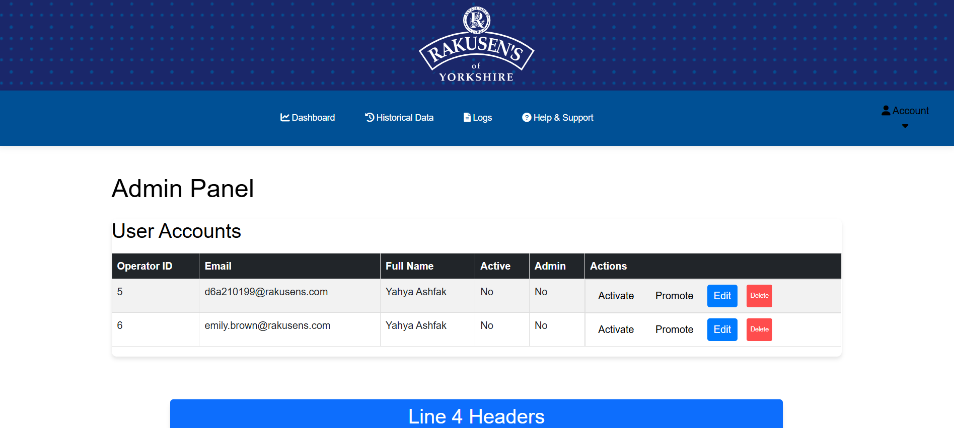

## Layout Description:

## Fonts:

* Font family is inherited from Bootstrap and browser defaults.
* Icons are rendered using Font Awesome classes (e.g., .fas, .fa-sun, .fa-moon).

## Colors:

* Bootstrap primary (blue) and success (green) are used in headers.
* Table header uses .table-dark for dark background.
* Footer uses bg-dark and text-white for contrast.

## Text and Text Styling:

* Headings use <h1>, <h2> with Bootstrap margin classes like mb-4.
* Buttons use classes like .save-btn and text appears directly inside HTML tags.
* Links in the footer are styled with text-white and are underlined on hover (via default Bootstrap styling).

## Spacing and Layout:

* Bootstrap’s grid system is used extensively (e.g., .container, .row, .col-lg-8).
* Padding and margin are managed through Bootstrap spacing utilities (e.g., py-4, mb-4, p-0).
* Centering achieved using text-center and justify-content-center classes.

## Container and Widget Styles:

* Admin content is wrapped in .admin-panel inside a .container-fluid.
* Card components are used to group sensor tables.
* Modal is structured with .modal and .modal-content.
* Table containers use .table-responsive for overflow control.

## Widget-Specific Styles:

* User Account Table: Bootstrap table with striped, hover, and dark header styles.
* Modal Form: Includes fields for editing user details like email, name, and password.
* Sensor Header Tables: Separate cards for Line 4 and Line 5, each with a table of sensor headers.
* Dark Mode Toggle: Custom toggle styled with icons for light and dark themes.

## Responsive Design:

* Bootstrap 5 classes handle responsive behaviour.
* Container widths adjust based on screen size (col-lg, col-md, col-sm).
* Tables wrapped in .table-responsive to prevent overflow on smaller screens.

## Images, Logos, and Other Visual Elements:

* Logo: rakusens_logo.svg positioned in the center of the main-header using CSS transforms.
* Favicon: rakusens_tab_logo.png linked in the <head>.
* Icons: Font Awesome used for toggle icons (sun and moon).

## Links to Other HTML/CSS/JS Pages:

Navigation bar links to: home.html, help.html (others are placeholders).

External CSS includes:

* + Bootstrap CDN
  + Font Awesome CDN
  + ../css/home.css
  + ../css/admin.css
  + ../css/account.css
  + ../css/dark-mode.css

External JS includes:

* ../js/admin.js
* ../js/logged-in.js
* ../js/dark-mode.js

## Bootstrap Links:

* Bootstrap CSS: https://cdn.jsdelivr.net/npm/bootstrap@5.3.0/dist/css/bootstrap.min.css
* Bootstrap JS: https://cdn.jsdelivr.net/npm/bootstrap@5.3.0/dist/js/bootstrap.min.js
* Bootstrap utility classes extensively used for layout, alignment, responsiveness, and styling